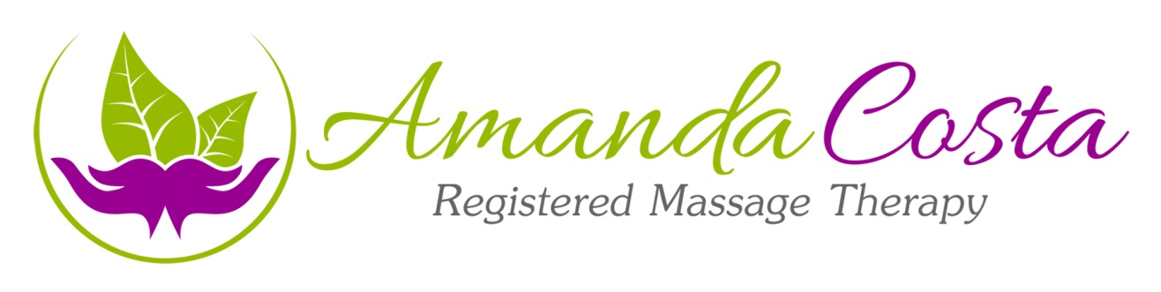

What is an Epsom Salt bath?
The use of Magnesium Sulphate (Epsom Salt) in a hot bath to promote increase circulation, detoxification and elimination. Epsom salt is a naturally occurring mineral and is a proven remedy to treat muscle soreness, aches and pains. It can also help to reduce stress

Why take an Epsom Salt bath?
It is recommended to take an Epsom Salt bath after a massage, especially for a first time client and when deeper work has been incorporated into your treatment

What are some benefits of Magnesium Sulfate?

- Eases stress
- Reduces inflammation to relieve pain
- Improves concentration and quality of sleep
- Helps muscles/nerve to function properly
- Regulates the activity of over 325 enzymes in the body
- Improves oxygen use
- Flushes toxins
- Improves absorption of nutrients
- Helps prevent or ease migraine headaches
- Helps prevent artery hardening and blood clots

What will you need?

- A bathtub
- A thermometer (if available)
- A water bottle nearby to ensure ample drinking water
- 1-4 cups of Epsom Salts (depending on the size of your tub)
- A visible clock to monitor the duration of your bath

Directions for taking an Epsom Salt bath:
- While filling the tub with hot water, gradually dissolve the salts to prevent clumping (39-44 degrees keeps water comfortable and adjust temperature accordingly)
- Make yourself comfortable in the bath with as much of your body submerged if possible ( if you have a heart condition; and have consulted your physician, modify this bath and remain in a semi seated position with the water below your heart level)
- Throughout your bath be sure to make small body movements with your bands and/or feet, as you do not want to lay motionless for a prolonged period while in the bath
- Sip your drinking water regularly and add a cool compress if needed to your head or chest.
- Remain in the tub for 10-20 minutes, then pull plug and allow water to drain before standing up. Follow your bath with a cool shower to rinse off excess salt and replenish the pH of your skin. Pat skin dry.
- Minimum 30 minutes rest after bath (ideal before bed)
NOTE: Should you experience any undesired effects such as dizziness or nausea, immediately drain the tub, remain seated and drink water until the feels subside.
- Consult your physician for any contraindications before taking an Epsom salt bath.
For more information about Epsom Salts; refer to Epsom Salt Council.org

